**FUNCTIONS**

1. User-Defined Function

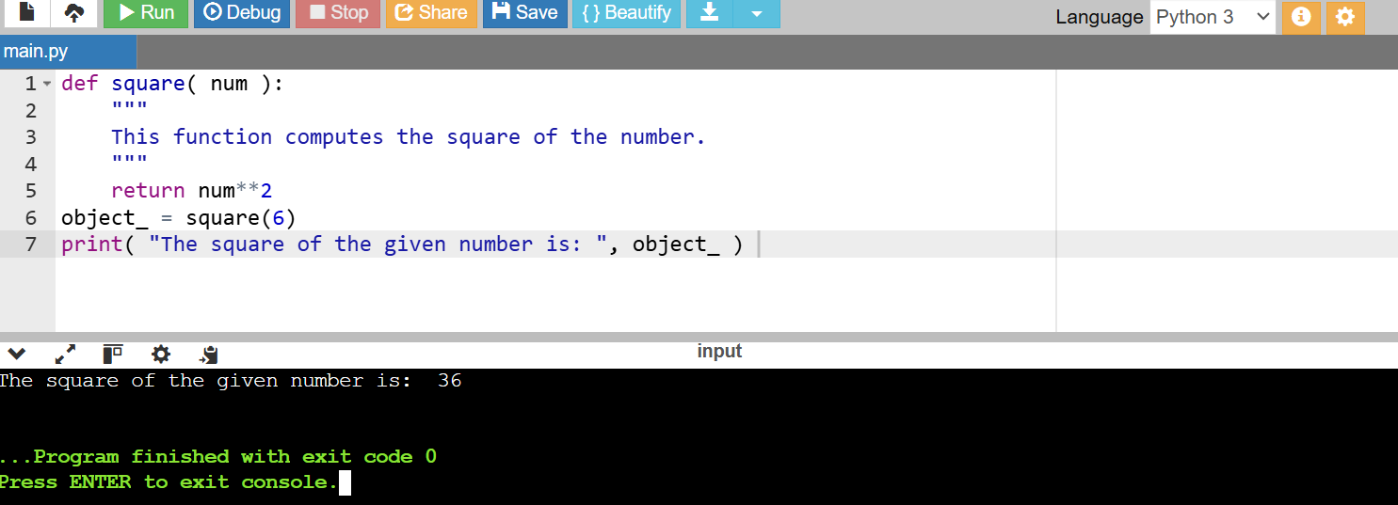

2. Calling a Function

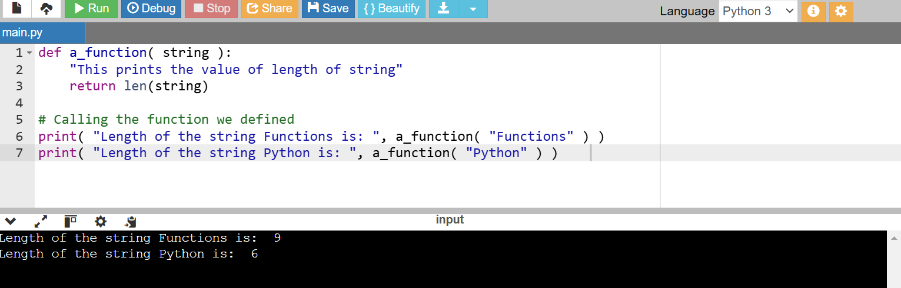

**Pass by Reference vs. Pass by Value**

1. 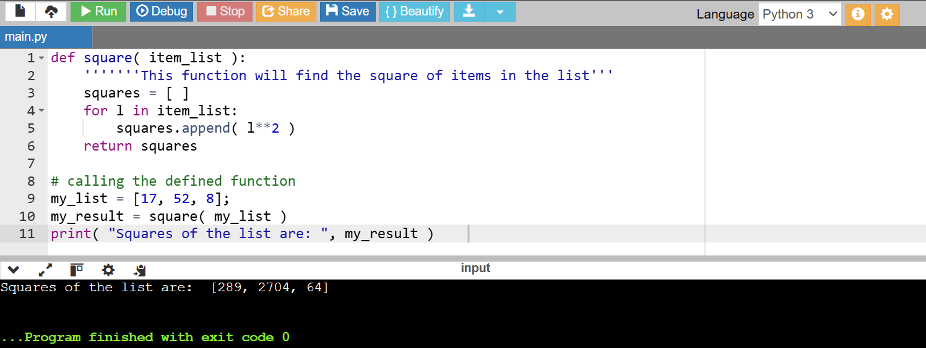

2. return Statement

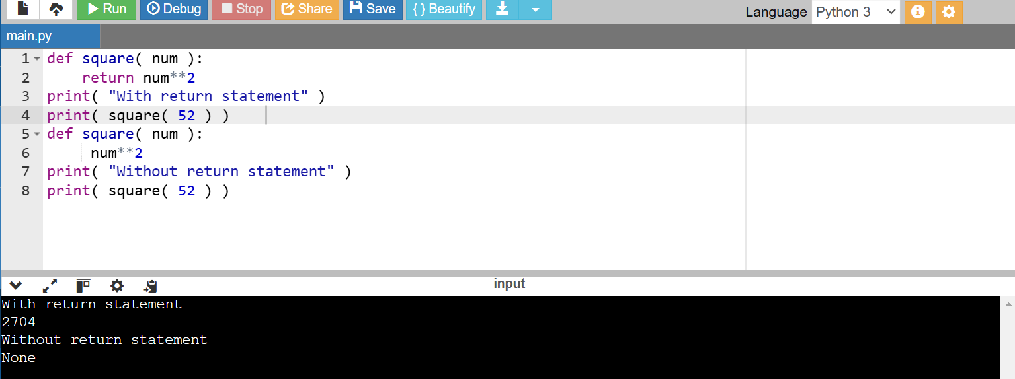

The Anonymous Functions

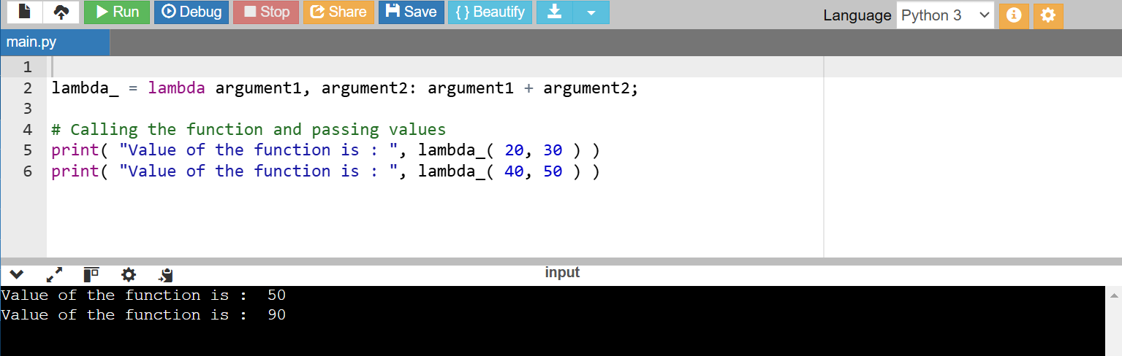

**PYTHON BUILT-IN FUNCTIONS:**

1. 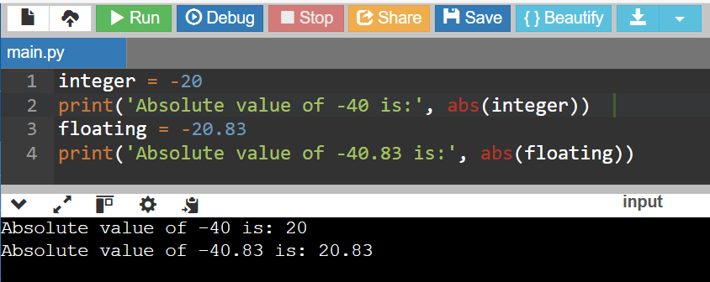

2. 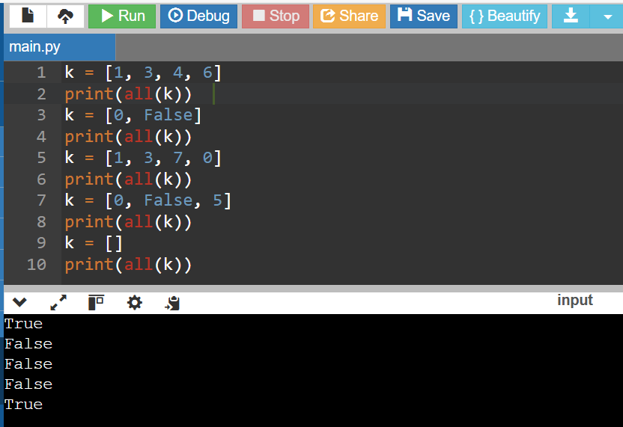

3. 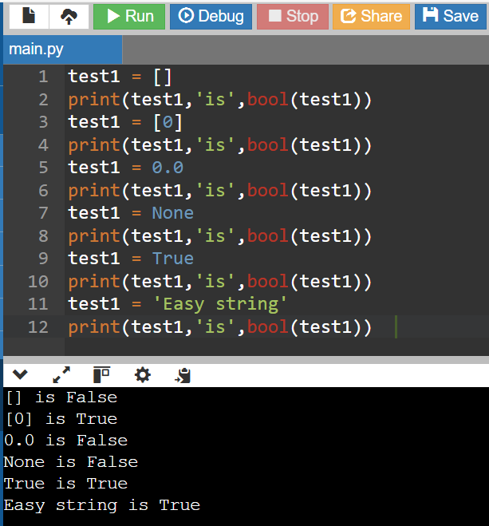

4. 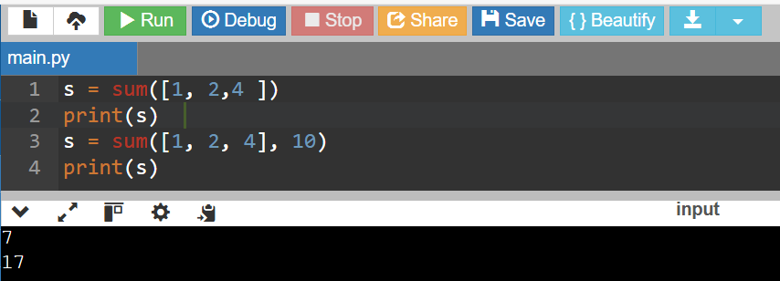

5.

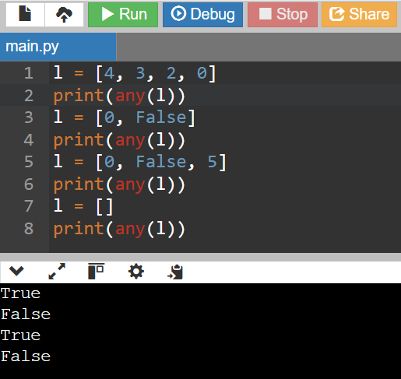

**LAMBDA FUNCTIONS:**

1.

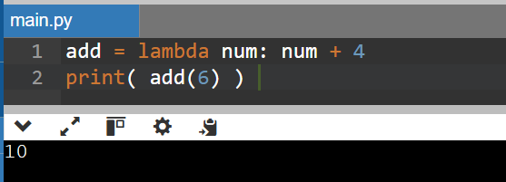

2. 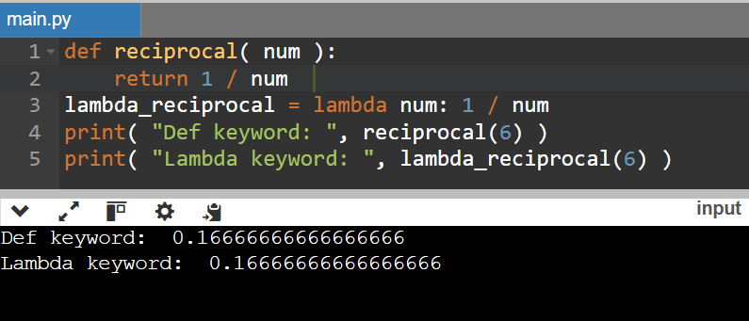

3.

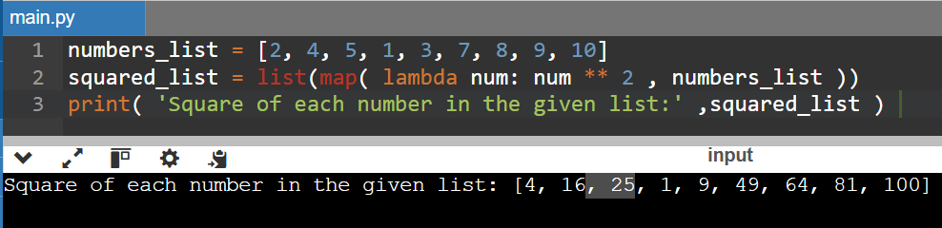

4.

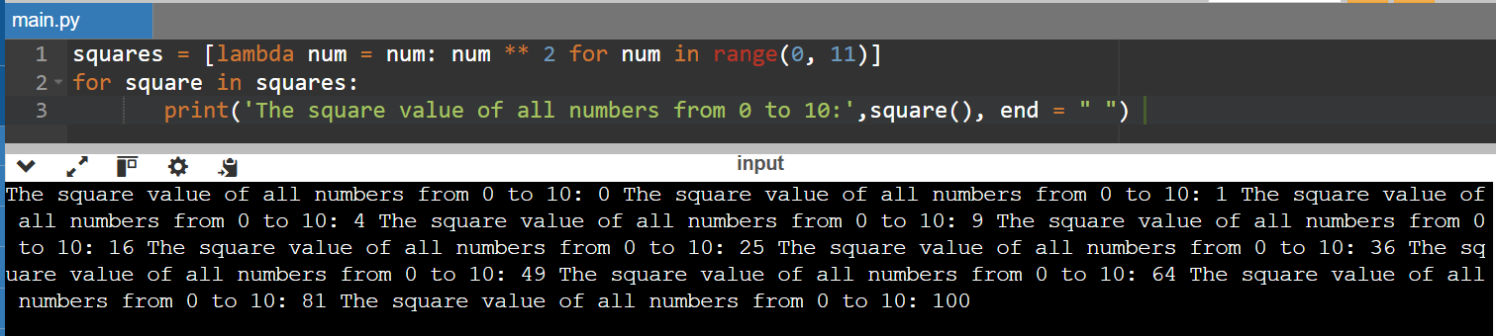

5.

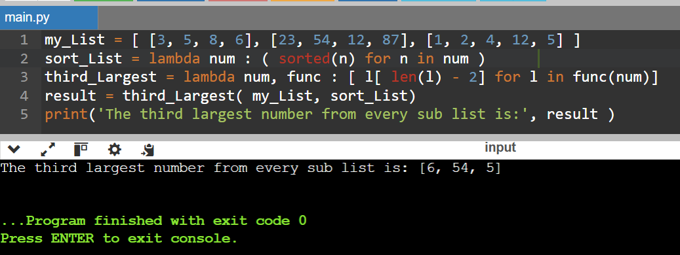

**MODULES**

1.

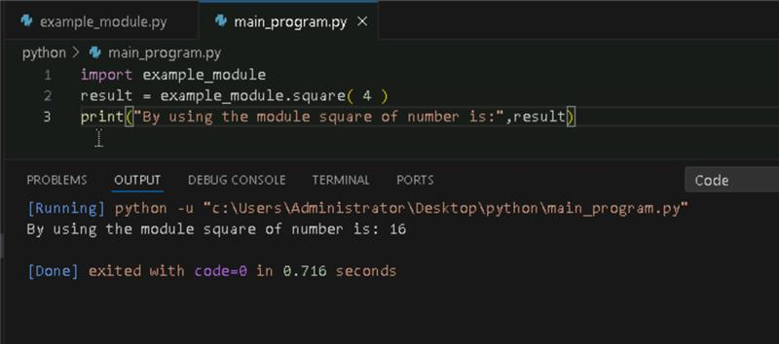

2. **Importing and also Renaming:**

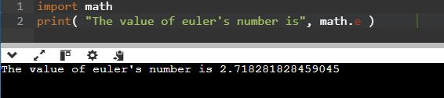

3. **Python from...import Statement:**

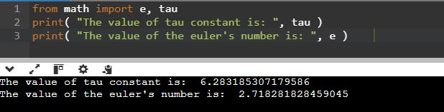

4. **Import all Names - From import * Statement:**

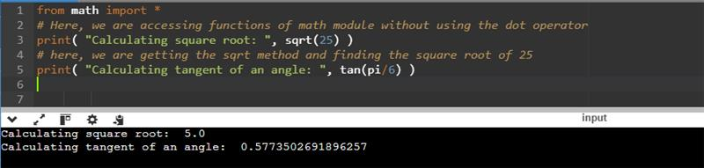

5. **Locating Path of Modules:**



6. **The dir() Built-in Function:**

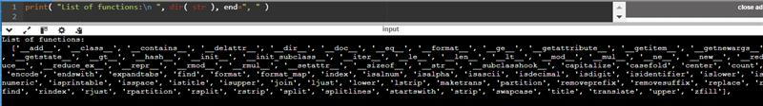

7. **Namespaces and Scoping:**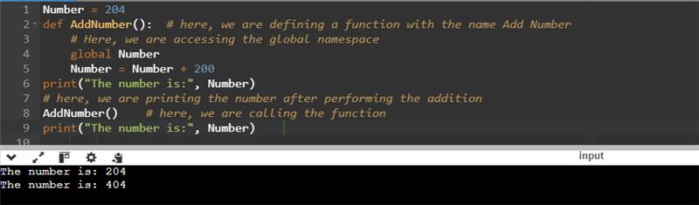

**PYTHON ARRAYS**

1. **Accessing array elements:**

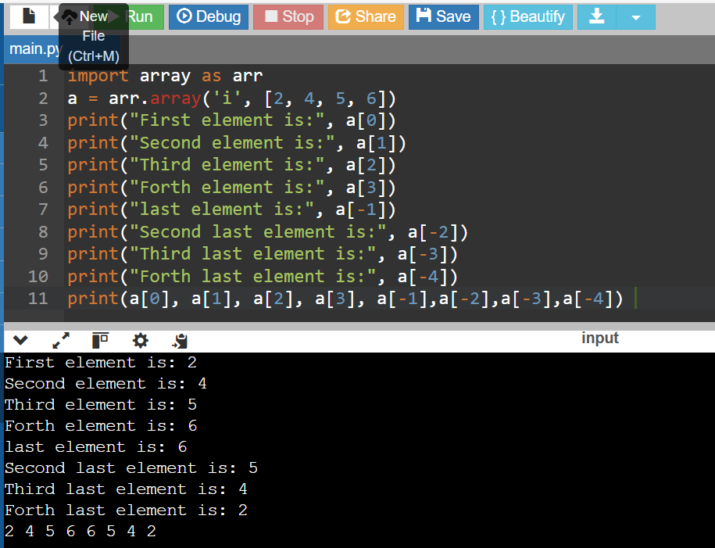

2. **Deleting the elements from Array**

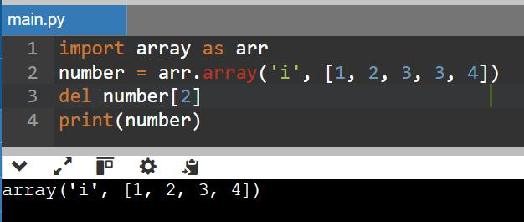

**3. Adding or changing the elements in Array**

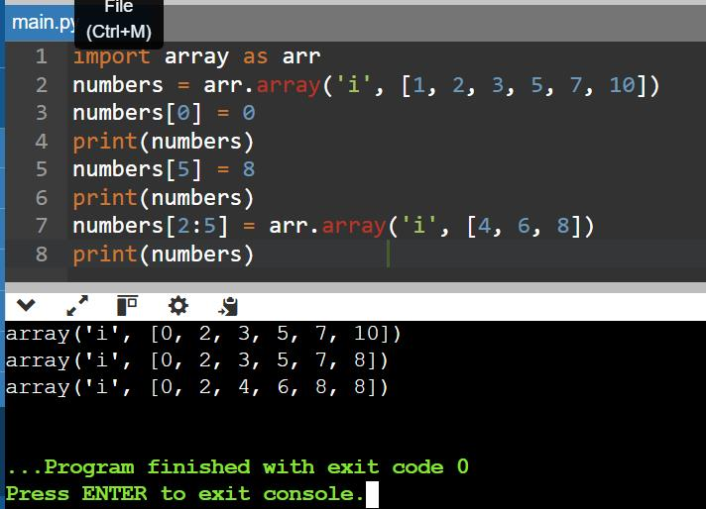

**4. To find the length of array**

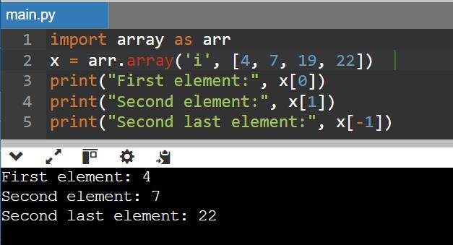

**PYTHON DECORATOR**

**1.**

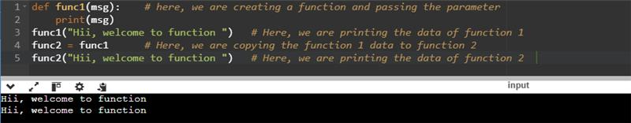

**2. Inner Function**

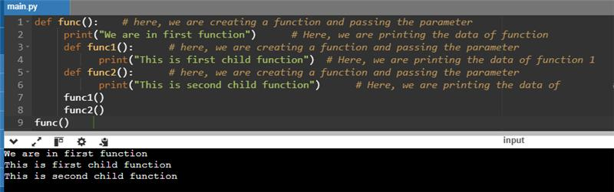

3.

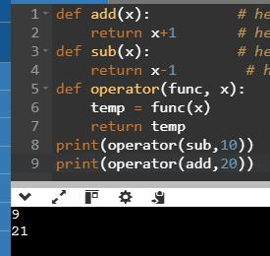

4.

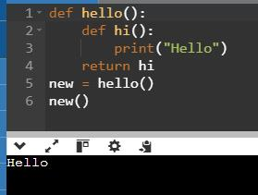

**Decorating functions with parameters:**

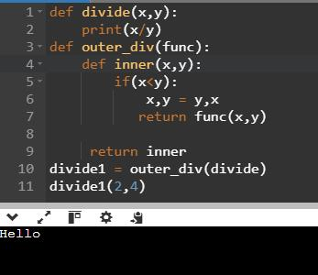

**Syntactic Decorator:**

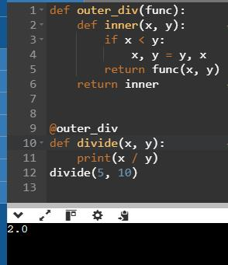

**Reusing Decorator**

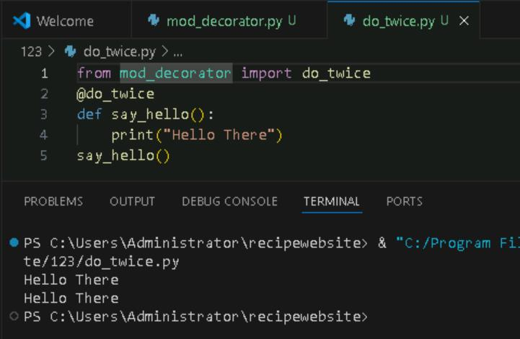

**Python Decorator with Argument**

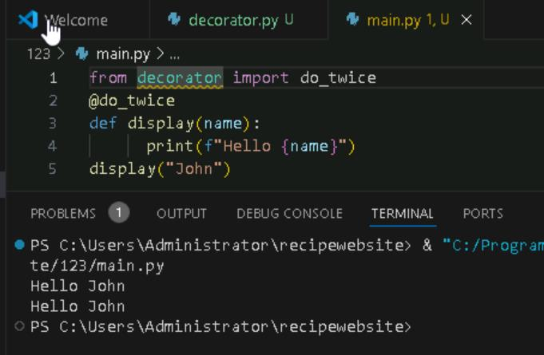

**Returning Values from Decorated Functions**

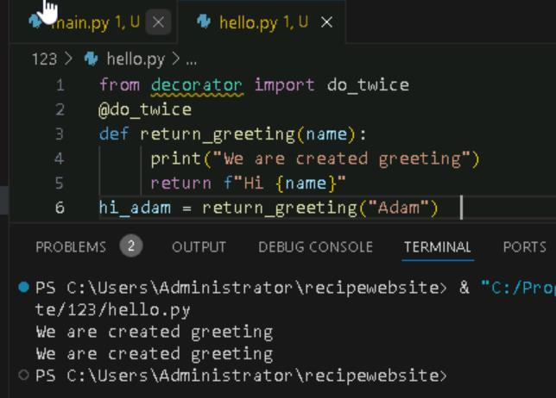

**Fancy Decorators**

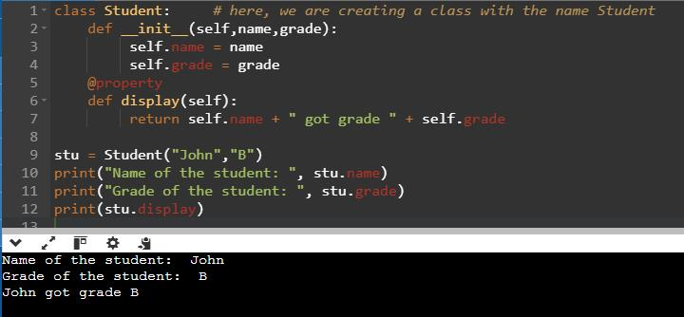

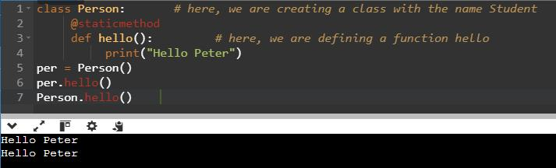

**Decorator with Arguments**

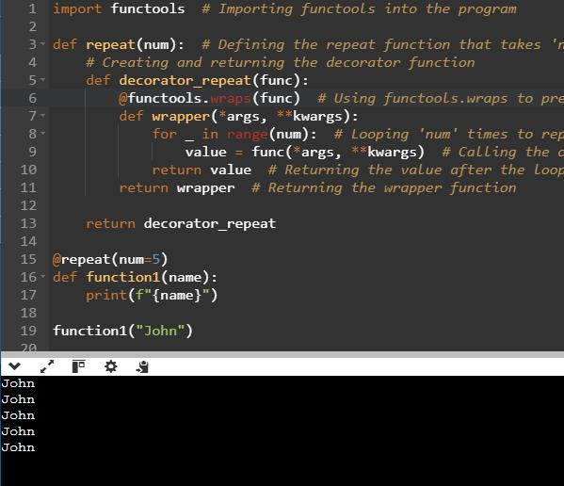

**Stateful Decorators**

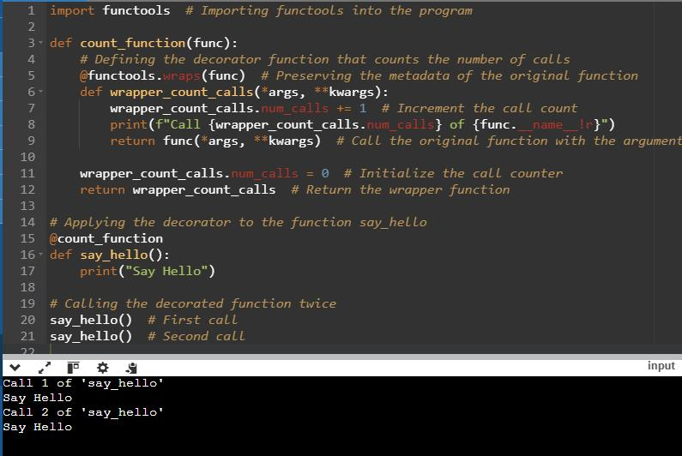

**Classes as Decorators**

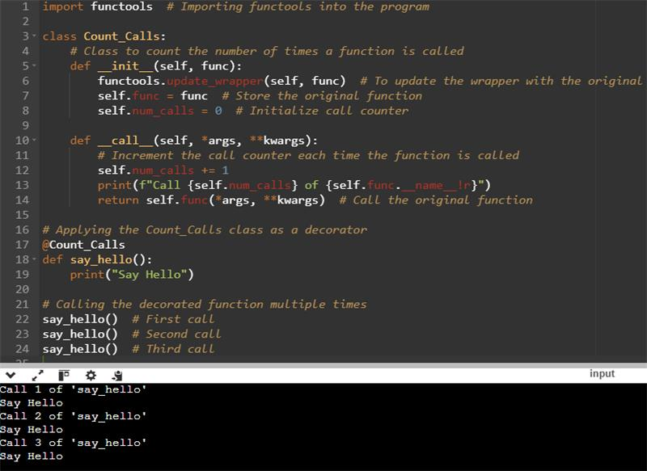

**PYTHON GENERATORS**

**1. To create Generator function in python**

**1. Using multiple Yield Statement**

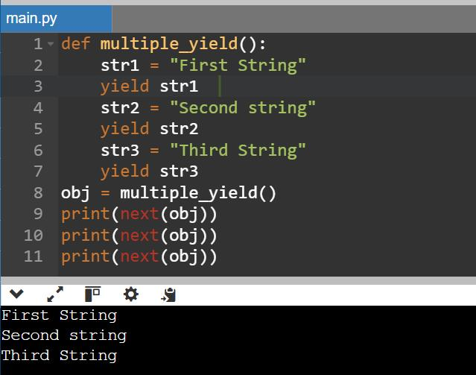

**1. Generator Expression**

**1. Multiplication table using Generators**

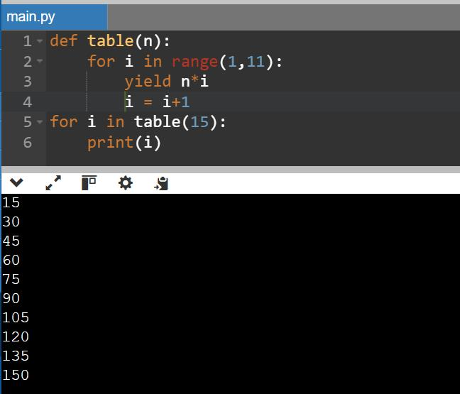

**1. Using next () on Generator Object**